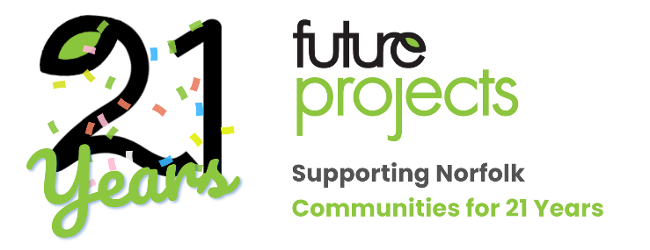
Charity Golf Day
Barnham Broom Golf & Country Club
Friday 22nd September 2023
We are raising funds for Future Projects 21st birthday to grow our services to support more local people in need through Future Support, Education and Radio. There’s more information about the campaign here.
We are looking for sponsors who would like to support our cause and gain visibility in the community.
We are offering one headline sponsorship opportunity for the event. As a sponsor for our charity golf day you will have the opportunity to showcase your brand in front of a highly targeted audience of golf enthusiasts, community leaders, philanthropic individuals and all Future Projects’ stakeholders.
In return for your sponsorship you will receive:
- Brand exposure – sponsoring our golf day can provide a significant amount of brand exposure for your company. Your company’s name and brand logo will be prominently displayed on all promotional materials, such as banners and signage, press releases, social media posts (including through Future Radio’s popular accounts) and subject to their attendance, the Norfolk Magazine. Additionally your company has the opportunity to provide branded merchandise, such as golf balls or tees, to players and attendees.
- We are also offering a radio advert to be played on Future radio, our community radio station.
- Positive Association – demonstrating your commitment to supporting the local community and having your organisation known as a supportive partner of Future Radio, Education and Support and all the services it provides to help local people and communities.
- Networking Opportunities – Charity golf days are attended by influential people from various industries. Sponsoring the event can provide your company with an opportunity to network and build relationships with potential clients, suppliers and other important contacts.
- Tickets for one team of 4 to attend the day, including setting off from 1 of 3 prime holes closest to the hotel.
All sponsorship opportunities are offered on a first come first served basis, with only one headline sponsor for the day. The opportunity will be given to the first organisation to submit a registration form confirming sponsorship of the Golf Day.
By sponsoring our charity Golf Day you will help make a meaningful difference in the lives of those in need, while gaining valuable exposure for your business.
Please let us know if you are interested in discussing sponsorship opportunities further and we will be happy to arrange a meeting or call at your confidence.
Thank you for supporting us for this event.
As always if you have any queries then please do not hesitate to contact us on 01603 250505 or info@futureprojects.org.uk
Price for the main event sponsorship: £1,800 + VAT
BACS payments to sort code 40-30-28 A/c 81432605 with Company name as a reference.
Please let us know if you need an invoice raised.

