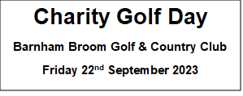

Company Name: ___________________________________________________________________
Lead Booking Name: ________________________________________________________________
Email: ________________________________ Telephone: _____________________ ____

Team Details
Team Name: _____________________________________________________________________
Player 2: __________________________________________________________________________
Email address: ______________________________________________________________________
Player 3: __________________________________________________________________________
Email address: ______________________________________________________________________
Player 4: _________________________________________________________________________
Email address: _____________________________________________________________________

Are you interested in any sponsorship?
Hole sponsorship £75 – Yes / No
Nearest the pin £100 – Yes / No
Beat the Pro £100 – Yes / No

Charity raffle
If you would like to donate a prize for our charity raffle / auction this year, to help raise extra funds and to be included in our list of prize donors, please get in touch with us at info@futureprojects.org.uk
Every prize is appreciated no matter how small!

Thank you for supporting us for this event.
As always if you have any queries then please do not hesitate to contact us on 01603 250505 or info@futureprojects.org.uk
Cost per team £320
BACS payments to sort code 40-30-28 A/c 81432605 with team name as a reference.
Please let us know if you need an invoice raised.

Please complete and email this form to info@futureprojects.org.uk

